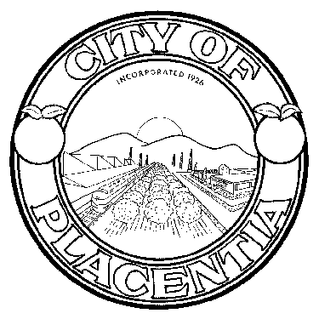
HERITAGE FESTIVAL COMMITEE
401 East Chapman Avenue
Placentia, CA 92870

NOTICE OF CANCELLATION DUE TO
LACK OF QUORUM
The
HERITAGE FESTIVAL COMMITTEE
Regular Meeting scheduled for
Wednesday, July 8, 2015
at 7:00 p.m.
in the Community Meeting Room
was cancelled due to lack of quorum.
* * * * * * * *
The next regularly scheduled meeting of the
HERITAGE FESTIVAL COMMITTEE
will be held at 7:00 p.m. on
Wednesday, August 12, 2015
in the Community Meeting Room
Placentia City Hall

***CERTIFICATION OF POSTING NOTICE***
I, Veronica Ortiz, Community Services Coordinator/Heritage Festival Committee Liasion, hereby certify that the Notice of Cancellation for the July 8, 2015 meeting at 7:00 p.m. Regular Meeting of the Heritage Festival Committee of the City of Placentia was posted on July 9, 2015.

Veronica Ortiz
Community Services Coordinator

