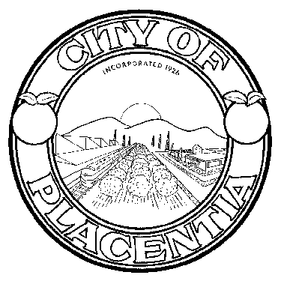
HERITAGE FESTIVAL COMMITEE
401 East Chapman Avenue
Placentia, CA 92870

NOTICE OF CANCELLATION DUE TO
LACK OF BUSINESS
The
HERITAGE FESTIVAL COMMITTEE
Regular Meeting scheduled for
Wednesday, November 11, 2015
at 7:00 p.m.
in the Community Meeting Room
will be cancelles due to lack of business.
* * * * * * * *
The next regularly scheduled meeting of the
HERITAGE FESTIVAL COMMITTEE
will be held at 7:00 p.m. on
Wednesday, November 18, 2015
in the Community Meeting Room
Placentia City Hall

***CERTIFICATION OF POSTING NOTICE***
I, Veronica Ortiz, Community Services Coordinator/Heritage Festival Committee Liasion, hereby certify that the Notice of Cancellation for the November 11, 2015 Regular Meeting at 7:00pm of the Heritage Festival Committee of the City of Placentia was posted on November 10, 2015.

Veronica Ortiz
Community Services Supervisor

